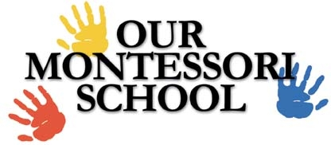

Information Packet

1111 EUBANK NE
ALBUQUERQUE, NM 87112
505-275-6111

Infant, Preschool & Kindergarten
Ages 6 weeks to 6 years

www.ourmontessori.com
l Welcome to OUR MONTESSORI SCHOOL, a not-for-profit organization, and the world of
Montessori Education! We are licensed through the New Mexico Children, Youth and Families
Department. We are a FOCUS 5-star facility. We have an open-door policy and families are welcome
to visit the school at any time. We also offer Montessori training and continuing education for teachers
throughout the state of NM. We follow a nondiscriminatory policy, accepting children of all races, creeds,
social and economic status.

MISSION STATEMENT: The purpose of Our Montessori School is to provide a unique, authentic Montessori education for children between the ages of 6 weeks and 6 years, Infant care, Toddler and Preschool, through kindergarten. Our Montessori certified teachers will guide children through the prepared Montessori environment. We believe that appropriate education received at these early ages creates a love of learning for a lifetime.

PHILOSOPHY STATEMENT: The Montessori Philosophy states that children have sensitive learning periods especially between the ages of 6 weeks and 6yrs, and that each child learns at their own individual pace. It is during these early years that each child’s individual gifts and abilities will be encouraged and supported to reach his/her maximum potential. You will find classrooms filled with fascinating and colorful learning materials that children can utilize individually or with their peers. The children will be introduced to individual as well as, group lessons to encourage their learning through peer relationships and play. We will introduce new activities in practical life, sensorial, math, language, geography, cultural and science curriculum to your child individually, when he/she is developmentally ready. Also, through a Montessori approach, we offer activities in art, Spanish, yoga, sign language, gardening, science, cooking, P.E., and music, creating a fulfilling experience for each child. We view your child’s presence in our school as a privilege and look forward to a rewarding school year!

FUNDRAISING: Our Montessori School is a not-for-profit organization; we will conduct various fundraising programs throughout the school year. We would like it if each family could participate in at least one fundraiser per school year. Fundraising is key to providing additional funds for Montessori materials and continuing training for our staff and families.

GUIDANCE PHILOSOPHY
The specific goal of experience in the Montessori environment is inner discipline. OUR MONTESSORI SCHOOL’S positive discipline philosophy meets the children’s need for guidance and supervision; helps them to achieve self-direction; and provides rules and limits to teach self-control. The school believes in a guidance system based on positive reinforcement, mutual respect between staff and children, and fair, consistent rules. Respect for the child is a number one tenet, it is recognized that each child is an individual who is moving toward the goal of inner discipline and self-control.

HOURS OF OPERATION
OUR MONTESSORI SCHOOL is open from 7:00 a.m. – 6:00 p.m., Monday through Friday. Please note exceptions to this schedule on the Annual School Calendar. The school day is divided into morning
(9:00 a.m. – 12:00 p.m.) and afternoon (1:00 p.m. -3:30 p.m.) classes.

SNACK
Snack is served 3 times each day. There is a monthly snack fee that will be charged to your account based on your child’s schedule.

NUTRITION/ LUNCH
Children will bring sack lunches to school. We request that lunches be balanced and nutritious. We cannot heat or refrigerate student lunches. On Friday’s cheese pizza is offered with fruit and vegetable and juice or milk for a fee of $4.00 which will be billed monthly.
BASIC CLASSROOM DAY

The infant classroom has a specific schedule to help accommodate children’s individual needs. The following is a basic schedule observed in the Toddler and 3-6 yr classrooms.

7:00-8:00 Inside activities
8:00-9:00 Outside on playground/separate Toddlers & 3-6
9:00- 12:00 AM Program/Montessori environment/individual work time
11:00-11:30 Toddler Recess
11:30-12:00 Toddler Lunch
12:00-12:30 3-6 Recess (12:00, 12:05, 12:10)
12:30-1:00 3-6 Lunch (12:30, 12:35, 12:40)
1:00 – 2:30 Rest for 3-6 – non-nappers individual work
2:30 – 3:30 PM Program/ Montessori environment/ individual work time
3:30-4:45 Outside on playground/separate toddlers & 3-6
4:45-6:00 Inside Activities/ Story time/Individual work

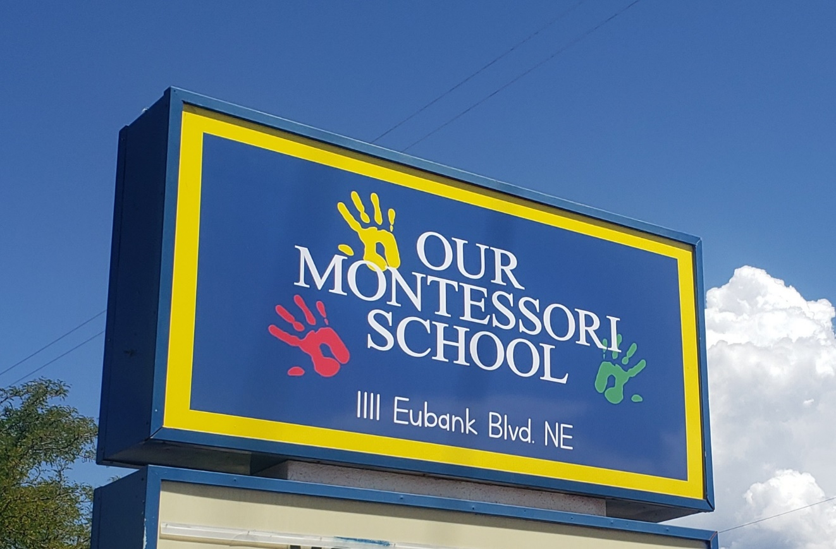

Our Teaching Staff
3-6 Classroom – Lizette Wilson
I fell in love with the Montessori philosophy after enrolling my son in the toddler classroom where I was fortunate to be able to work as an assistant. I began my Montessori training in 2007 and received my NAMC teaching certificate in 2008. During that time, I worked with children with special needs and applied the Montessori philosophy. When my daughter turned 2 in 2009 I enrolled her at OMS and was able to work here as well. I began working at OMS as a teaching assistant working part time while still attending school to pursue my elementary teaching degree. I took 1 year off for maternity leave and returned to OMS in 2014 as a lead teacher. I am happy to be back with the OMS family.
3-6 Classroom – Denise Tapia
I have been with Our Montessori School since 2004. I have always loved working with children. My original intention when I went to college was to get my degree in education. As it happens so often, I changed my degree to Sociology with the intent to work in counseling with children and families. I graduated from the University of New Mexico with my bachelor’s degree in Sociology. I worked in many different corporate positions before realizing that my heart was still leaning toward working with children. I began as an assistant and also running the summer program here which I really enjoyed. I decided to get my Montessori teaching certification through NCME. When I became a lead teacher I found that following my heart to teach was definitely the right decision for me.
3-6 Classroom – Cindy Johnson
I started my Montessori teaching career in 1996 at Our Montessori School. I joined the staff as a Classroom Assistant and two years later became a Lead Teacher in a 3-6 classroom. I completed my NCME Montessori Teacher Certification in 2000. That same year my family and I moved to California where I worked at Little Blossoms Montessori for a year as a Lead Teacher and then moved into Administration at Sacramento Montessori where I worked for three years as the Director. I returned to Albuquerque and OMS in 2004, where I have enjoyed teaching in the 3 – 6 classroom environment.
3-6 Classroom – Mary Maffucci
My name is Mary Maffucci, and my interest in working with children began in high school and an internship with a local elementary teacher. I have been with OMS since 2023 and have developed a deep appreciation for Montessori philosophy, especially after seeing how the materials support student growth and independence through the prepared environment. I recently earned my NAMC Teaching Diploma for ages 3–6. I am continually inspired by the growth children experience through hands-on learning in the Montessori classroom. I look forward to bringing my passion for the Montessori Method into the classroom each day.
3-6 Classroom – Graciela Chavez
My name is Graciela Chavez, and I have been part of the OMS community since 2022. I earned my Montessori certificate in January 2024, which deepened my understanding of the Montessori approach and how children learn best through hands-on experiences. I value the Montessori philosophy because it supports the development of the whole child. I especially appreciate how it encourages independence, self-motivation, and concentration. In the classroom, I focus on building genuine connections with each child and creating a supportive learning environment while recognizing that each child has a unique need or desire.
Toddler Classroom- Rebecca Myers
I began teaching the Montessori method in 2015 after completing my student teaching at another Montessori school. I graduated from CNM with my associate’s degree in early childhood Multicultural Education and a certificate in Child Development. Upon graduation, I became a Lead Teacher in a Montessori classroom. I began teaching in the Toddler Classroom at Our Montessori School in 2016. My passion for working with children has been long lasting as I watch my own three children grow and learn.
Infant Classroom – Elyse Troglin
I grew up at Our Montessori School since I was 10 years old. I officially started working in the classrooms in 2012. I have worked with ages 2-6 but always wanted to work with infants. When the opportunity was presented, I quickly and happily said “yes”! I received my Montessori Certification in 2022 from NAMC and previously completed my Child Development Certificate. I have truly enjoyed this adventure and am so excited to continue this journey at OMS.

MONTESSORI PRESCHOOL INFORMATION

- Why should I send my child to Preschool?
Most educators and psychologists today agree that the single most important period in the development of a person’s intelligence occurs between birth and age five. A child’s mind is extremely absorbent and his curiosity is at a peak during these early years. When properly nourished and stimulated, the child’s mind forms patterns for learning that serve him well throughout his life. The Montessori system of preschool education has proven to be one of the most effective and fastest growing methods to guide a child through these critical years.

- What is the difference between Day Care, Nursery Schools and Preschools?
Day Care Centers are generally for the purpose of caring for children on an all-day basis. Nursery Schools are generally experiences in socialization and play. Preschools are oriented toward educational experiences combined with socialization and play.
- How is a Montessori Preschool different from other Preschools?
In most preschools the children are taught educational concepts in a group by a teacher. In a Montessori Preschool the children learn concepts spontaneously as they work independently with the many materials in the environment.

- What is the Montessori Method of Education?
The main purpose of the Montessori Method is to develop an environment where the child can unfold spontaneously and manifest the greater person within. According to Maria Montessori, “the child is the father of the man”. As the child begins to develop this inner self, his love of life and learning expands continuously.

- Who started the Montessori Method?
Dr. Maria Montessori, over 100 years ago, was Italy’s first woman medical doctor. Using her scientific background, she began observing children in Rome. Based on her unbiased observations she developed unique materials, a child-center environment, and was one of the first persons to revolutionize educational thought by stressing respect for the child, freedom of expression, self-education, and training through use of movement and the senses.

- What is in a Montessori classroom?
The Montessori classroom is a child-size world. Whatever is in the world outside can be incorporated meaningfully in the Montessori classroom. To a child, the world is unmanageable – it is too big, too complex and too confusing. By careful selection of materials by the teacher, an environment is set up that allows the child a place to explore life on a level he can understand. The materials or exercises are designed to stimulate independent exploration. This prepared environment entices the child to proceed at his own pace from simple activities to more complex ones. Through this process, the child’s natural curiosity is satisfied and he begins to experience the joy of discovering the world about him. Materials and curriculum center around Practical Life, Sensorial, Language, Math, Geography, History, Science, Art, Music, Drama and Dance.

- How do children interact in the environment?
As the children develop their sense of pride in their “work”, a feeling of confidence, wellbeing and joy begins to manifest itself in the child. A “new child” is born. A classroom of Montessori children is a joy to watch. There seems to be a spirit of respect, love and cooperation among the children.
- What is the role of the Montessori Teacher?
The Montessori Teacher is sometimes called a Directress because she facilitates the classroom activity. She carefully plans the environment in the interests of the children, and she helps the children progress from one activity to the next. She is trained to deal with each child individually, allowing him to choose from many activities within his range of ability. She stands back while a child is working and allows her the satisfaction of her own discovery.

- With all the freedom, isn’t there confusion?
The concept of freedom in the classroom is a freedom within limits. A child is allowed to work freely so long as he does not disturb others. Actually, the children having the freedom to follow their interests are generally happy and busily involved in their work.
- What is the best age to start a child in a preschool?
Maria Montessori outlined various periods of “sensitivity”. During these times, a child is more capable of and interested in learning specific concepts. At age 2 ½ - 3 a special sense of order, concentration, coordination, and independence begin to emerge. This time is ideal to begin a child’s training in Montessori as he is at the perfect period to build a strong foundation for future learning.
- How do Montessori children adjust to public school?
Children who have been in a Montessori environment are generally very flexible and adjust quite easily to the public school situation. They may be better students and spend their time in more productive ways because of their self-direction and positive attitude toward learning.
- Why is a Montessori experience for five days each week?
The Montessori classroom experience is for five consecutive days in order to allow the spontaneous learning of the child to flow smoothly. A child taken in and out of school every other day does not have the same opportunity to pursue his unfolding interests.
- What about socialization and group work?
Socialization is very much a part of the Montessori method. In the classroom you’ll notice children interacting continuously, choosing to work on projects together, and older children helping younger ones. Each day there is some group activity and play outside.
- Who is the Montessori Method designed for?
The Montessori Method is an “approach to learning” and as such has no distinctions of class or intelligence. It has been used successfully in all parts of the world and in all types of programs, i.e. Head Start, gifted children, special needs children, average children, etc.
- Isn’t Montessori expensive?
Tuition in Montessori preschools throughout the country is sometimes higher than other preschools because of the extensive materials, encompassing environment, curriculum, and trained staff. It is, however, a very reasonable cost in contrast to other activities you would plan for yourself or your child. It becomes a matter of what you value most. To give your child the finest possible experience in his most sensitive years is to give him a strong foundation throughout his life and probably ward off investment later to correct or remedy that which was missed. Many educators believe that it is wiser to invest in a child’s preschool education than his college education. The child who enjoys learning and becomes self-directed at the critical preschool age will benefit through all his years of learning. The expense now is a profitable long-term investment!

- How long is the school year?
The regular program begins in August and continues through May. A special summer session (a separate tuition) runs for eleven weeks during each summer if you are enrolled in Plan B, Plan A includes the summer session.

- Does Montessori employ current research and theory in educational methods?
Montessori is not a static or closed system of education. While there are certain didactic materials and methods that have been proven effective through the years, Montessori is as much an attitude about education and children as it is a specific method.
- Do you encourage Parent Involvement in the school?
We encourage parent involvement through conferences, observations, discussions, parent workshops, assisting in the classroom, making materials, etc. The staff feels that the more parents can understand the experiences of the child in the classroom, the better able they are to follow through at home. When parents follow through at home, the child benefits even more because he has a consistent environment in which to grow and develop.

- What is the training of the staff?
The Director-Administrator of the Montessori Preschool is credentialed by the National Administrators Credential and licensed by the State of New Mexico as a qualified Director of a Preschool facility. Each classroom is headed by a Director or Directress who has had specific Montessori training from an approved Montessori Training Center. All assistants are selected on the basis of their awareness of the child and dedication to the principles of child development. Students in training from Montessori teacher preparation programs may also be present in the classroom.

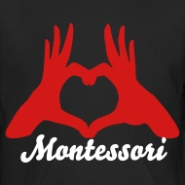

Revised 5/27/26

